Our idea
Our idea for the zero robotics 2019 project is the development of cyanobacteria and yeast, which are complementary bacteria. As the former need carbon dioxide to produce oxygen, while the latter need oxygen to produce carbon dioxide.

-Mission objective
Our idea is to exploit sunlight by using different convergent and divergent lenses combined with mirrors, which will canalize the light into a concentrated ray. This ray will then be chromatically modified and used to radiate cyanobacteria. The latter will produce oxygen, which will be analyzed by a detector. Our goal is to see if changing the color of the radiated light, the levels of oxygen produced by cyanobacteria vary.

What are Cyanobacteria?
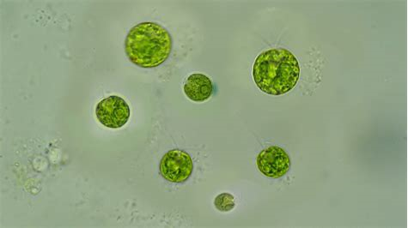
Cyanobacteria are photosynthetic bacteria, oxygen producers, also called blue or blue-green algae.
They belong to the type of cyanofitis and are distinguished from other bacteria by the presence of internal membranes (thylakoids) containing chlorophyll and other structures involved in photosynthesis. They are ubiquitous organisms that manage to live in extreme living conditions.
Fossils of cyanobacteria dating back more than three billion years have been found. These life forms were formed in an environment totally free of oxygen, and their appearance radically altered the living conditions of the planet, as their photosynthetic activity allowed the slow accumulation of oxygen in the atmosphere of our planet.

-Proposed method
By placing a converging lens slot in a wall of the cube, the light coming from the outside will be canalized into a focus. The ray is passed from a diverging lens to a convergent one, so as to obtain a single ray of light. This ray will be divided into two parts by a corner mirror that will direct the light to the sides of the cube. It will direct the light towards transparent circular filters composed of sections, each one of different color.
The light, after passing the filters, will pass through diverging lenses, which will widen the light beam, allowing a wide irradiation of the two sections of the cube containing the cyano-bacteria. They will begin the process of chlorophyll photosynthesis and, consequently, the production of oxygen.
The cyanobacteria are placed into a glass case having inside water with some sugar dissolved in it.
Two sensors will detect the levels of oxygen dissolved in water, which will be saved on a memory card to be studied.

-Experiment description
By placing a converging lens in a 5 cm circular slot in a wall of the cube, the light coming from the outside will be channeled into a focus that will not exceed a distance of 4 cm. Just before the focus a lens will be placed using an appropriate divergent angle in relation to the convergent angle of the first lens, will make all the transposed rays parallel to each other, thus constituting a single ray.
This ray will be divided into two parts by a corner mirror that will direct the light to the sides of the cube. The two constituted rays will again be reflected by two mirrors, which will direct the light towards transparent circular filters composed of sections of different colors. The two filters will be connected to an energy source and to a software that will determinate filters rotation.
The light, after passing the filters, will pass through diverging lenses, which will widen the light beam, allowing a wide irradiation of the two sections of the cube containing the cyano-bacteria. They will begin the process of chlorophyll photosynthesis and, consequently, the production of oxygen.
The cyanobacteria are placed into a glass case having inside water with some sugar dissolved in it.
Two sensors will detect the levels of oxygen dissolved in water, which will be saved on a memory card to be studied.

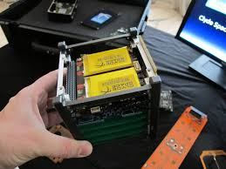

-Location of the experiment
As a place for the development of our project we think it would be the inside of the ISS, but it should have a hole to the outside to allow the entry of light, of course the hole will be protected by a glass. It is necessary to keep cubesat inside the ISS in order to maintain stable temperatures and pressure.

-Duration of the project
The preparation of the project in the field we think it cannot exceed one month, while the duration of the project in the space inside the ISS should not exceed fourteen days.

-Consumption of the cubesat
Since the motors inside the cubesat only have the task of turning two filters three times a day, at a speed not necessarily high. For this reason we have estimated that I consume around 50 mAh per day.

-Future purposes
1) As a possible future development we thought of implementing cubesat inside the station with larger dimensions and with a different shape using only cyanobacteria since CO2 will be produced by astronauts during normal breathing, in this way the station will be able to have an "oxygen generator" and can reduce the number of supplies or even cancel them if a greater quantity is produced.
2) As a possible future development, we thought of implementing cubesat on space suits and making it an integral part of the backpack allowing the astronaut to stay out longer and perform missions or long-lasting repairs.

