LIFE IN SPACE

A New Model for Studying Life Development in Extreme Deep Space Conditions

Memores acti, prudentes futuri


Unusual Programmers
12.15.2019
Project SAT-ZR

INTRODUCTION
When talking about interstellar voyages and colonization of other planets, we still have the impression of describing unimaginably distant realities and utopic goals unobtainable in the coming future. Apart from mechanical and financial deficits, the main reason why we regard this type of experiment out of reach is due to space-related issues. We have been living on the surface of our planet (or at most the oceans) for so long and adapted ourselves to its specific environment that we are totally unprepared to face the challenges that the deep space brings about: the extremely high and low temperatures, the absence of gravity, the vacuum (or low pressure), the radiations, and all the effects that these factors entail.

Luckily, we can count on our cousins-animals to help us investigate the universe as it has happened many times in the past. We decided to contribute to this research by analyzing two different and very peculiar organisms, both worth studying: The Tardigrades and the C. elegans. Our goal is to collect precise data on their rate of survival and find what physical factors come into play.

TARDIGRADES
Tardigrades are a phylum of invertebrates, about 1.0 mm long that live within layers of water. They can survive in extreme conditions such as water and oxygen shortage, high and low temperatures and pressures, exposure to high levels of radiation, and UV-A/UV-B/UV-C (in low percentages) rays. If placed in extreme conditions, they go into a defensive state called cryptobiosis, stopping the metabolic processes. These organisms return to their state of metabolic life prior to cryptobiosis when environmental conditions become hospitable again.

C. ELEGANS
Caenorhabditis elegans is a nematode worm, about 1 mm long, that lives in temperate soil environments. It has been used for many studies about neural development in animals and DNA repairing methods because of its easily approachable genome. Like tardigrades, it can go in a state of anhydrobiosis and live without water for several days.

PROPOSED METHOD
- The Tardigrades will go through a desiccation process with the use of a KNO3 solution.
- The C. Elegans will be put into a glass Petri dish with distilled water and then arranged on a desiccator. This process will take as much as a few days and will provide us with C. elegans in an anhydrobiosis state.
- DNA will be sequenced with the microarray method available on ISS.

PROCEDURE
The following procedure will be used for both organisms with slight changes.
- The first step is to gather living samples for each organism and keep them in a laboratory for preliminary analysis. As we keep track of their physical conditions, the subjects will be dehydrated (see proposed method number 1 and 2) and divided into three groups, one of which will remain on earth and observed as a comparison unit.
- The other specimens will be deployed in two separate aluminum sample carriers and arranged in two different sections of the CubeSat. In order to study the reaction of the organisms to UVs, we will isolate one of the remaining groups from UVs.
Precisely, the bottom section will be surrounded by a filter that won't allow the transmission of rays with λ < 320 nm(digital camera’s filters are a suitable option). The upper one will be left filter-less.
- The satellite is supposed to remain in close contact with the ISS, where samples will be rehydrated, and signs of their live activity will be monitored. A DNA sequencing, aimed to highlight the mutations occurred to key genes, will also be performed in space (see proposed method number 3). Then, as we gather microscopic data from each sample, we will test the macroscopic characteristics. Specifically, the ability to reproduce as we predict that a few of them might encounter sterility.
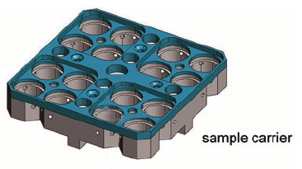
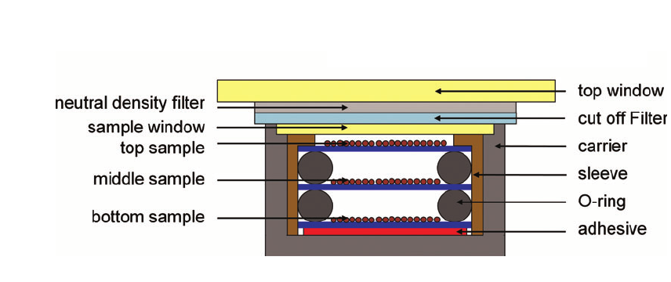
(Images purely for reference)

EXPERIMENT’S LIFETIME
Considering that the C. elegans life expectation (kept in a laboratory environment at a temperature of 20°C) is about 2-3 weeks, we planned the experiment to last at most 2 weeks. After this period spent outside the ISS, a group of astronauts will take the CubeSat inside the space station to analyze the samples.

SCIENTIFIC ASPECTS TAKEN INTO ACCOUNT
Since the CubeSat is situated in the International Space Station (ISS) at approximately 400 km altitude, the atmospheric pressure and drag are very small, and hence aerodynamic heating and convective heat transfer are negligible. Furthermore, there are three main sources of heat for general spacecraft systems operating in the near-Earth environment, which include the radiated heat from the sun, the albedo (the reflection of solar radiation) and planetary heating from the Earth. During the mission, at any given time the CubeSat will have at most three faces facing the sun, while the other faces were in the shadow facing and absorbing the earth’s albedo.
Considering ISS altitude and a probable beta angle (which determines the percentage of time that a satellite in low Earth orbit spends in direct sunlight, absorbing solar energy) of 56 degrees, the CubeSat will spend about 65 minutes exposed to the sun, and about 35 minutes in the eclipse region for each orbital period. When the CubeSat is facing the sun, its equilibrium temperature is about 297 K, or 24 °C, while when it is in the eclipse period, its average temperature is about 198 K, or -75 °C. These temperatures are suitable for our organisms because we sent them in an anhydrobiosis state.

PREVIOUS EXPERIMENTS
In September 2007, an experiment was conducted within the Biopan-6 experimental platform during the Foton-M3 mission. During ten days at low Earth orbit, samples of desiccated adult eutardigrades of the species Richtersius Coronifer and Milnesium Tardigradum were exposed to space vacuum and two different UV-radiation spectral ranges. The experiment included three sets of flight samples: samples exposed to space vacuum only, samples exposed to space vacuum and UVA/B, and samples exposed to space vacuum and UVALL. All samples were also exposed to ionizing solar and galactic cosmic radiation. Desiccated control samples were kept under ambient laboratory conditions but otherwise treated in the same way as flight samples. After the flight, the samples were rehydrated, and survival and reproductive patterns were recorded.

Another experiment (this time on Earth’s surface) has been carried out on C. elegans from a genetic point of view. The main subject of the research was the cep-1 (a transcription factor whose corresponding mammalian gene p53 is a tumor suppressor) which turned out to be the key to C. elegans’s genome damage repairing ability. The study involved wild-type animals and cep-1 mutants; the DNA damage was induced by ultraviolet type C (UVC) radiation or 10-decarbamoyl mitomycin C.

EXPECTED RESULTS
At least a few Milnesium Tardigradum are expected to survive, in continuity with the previous experiment’s results. It’s hard to determine what the C. elegans’ response will be. Independently from their final conditions, the analysis results will be important to determine their DNA-repairing system role in surviving.

REFERENCES (as to 12/05/2019)

- C. elegans experiment Tardigrade experiment
- Survival in space Survival in space(2) Survival in space (3)
- Cryptobiosis in larvae
- C. elegans' information C. elegans information (2)
- Tardigrade information
- CubeSat thermal model

